# File permissions in Linux

## **Project description**

This project is to demonstrate the various methods in Linux to set “file permissions” for various users. File permissions ensure that only concerned people have the right access to right information.

## **Check file and directory details**

We can print the file and directly details using “ls -la” or “ls -l”. “ls -la” is more comprehensive as it also includes the hidden files.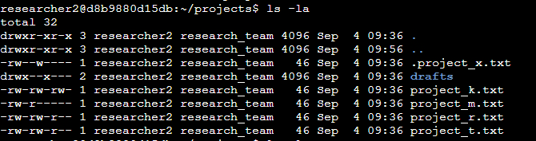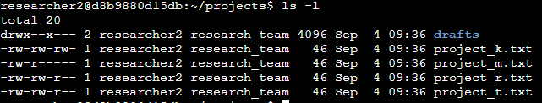

## **Describe the permissions string**

Permissions string consists of 10 letters.

First letter denotes “directory or file”. If directly then it will be “d” else “-“.

Next 3 letters are the permissions for **user** i.e., r = read, w = write and x = execution or run permissions.

Next 3 letters are the permissions for **group** i.e., r = read, w = write and x = execution or run permissions.

Last 3 letters are the permissions for **other** i.e., r = read, w = write and x = execution or run permissions.

If the permissions are present then corresponding letter will be there else “-“ will be there.

For example in below case:



-rw-rw-rw- Represents a “file” with read and write permission for each user, group and other. No execute permission exists for this file.

## **Change file permissions**

Permissions can be updated using the chmod command as below.

chmod o-w project_k.txt

Here “o” denotes the “other” “-w” denotes the write permission should be **REMOVED** for this user.

## **Change file permissions on a hidden file**

Permissions for hidden file can be changed like other files as shown below.

## 

chmod uo-w .project_x.txt

## Above command ensures that both “other” and “user” cannot write to this file.

## **Change directory permissions**

## Changing directory permissions is exactly like changing file permissions. Below command will ensure that directory “drafts” doesn’t have existing execute permission for directly drafts.

chmod g-x drafts

## **Summary**

## File permissions is one important thing to consider especially when it comes to cybersecurity. It ensures that only the people officially permitted to access the files are actually accessing them and no one else can access confidential files / data. Above commands and document lay out the whole process in-depth.